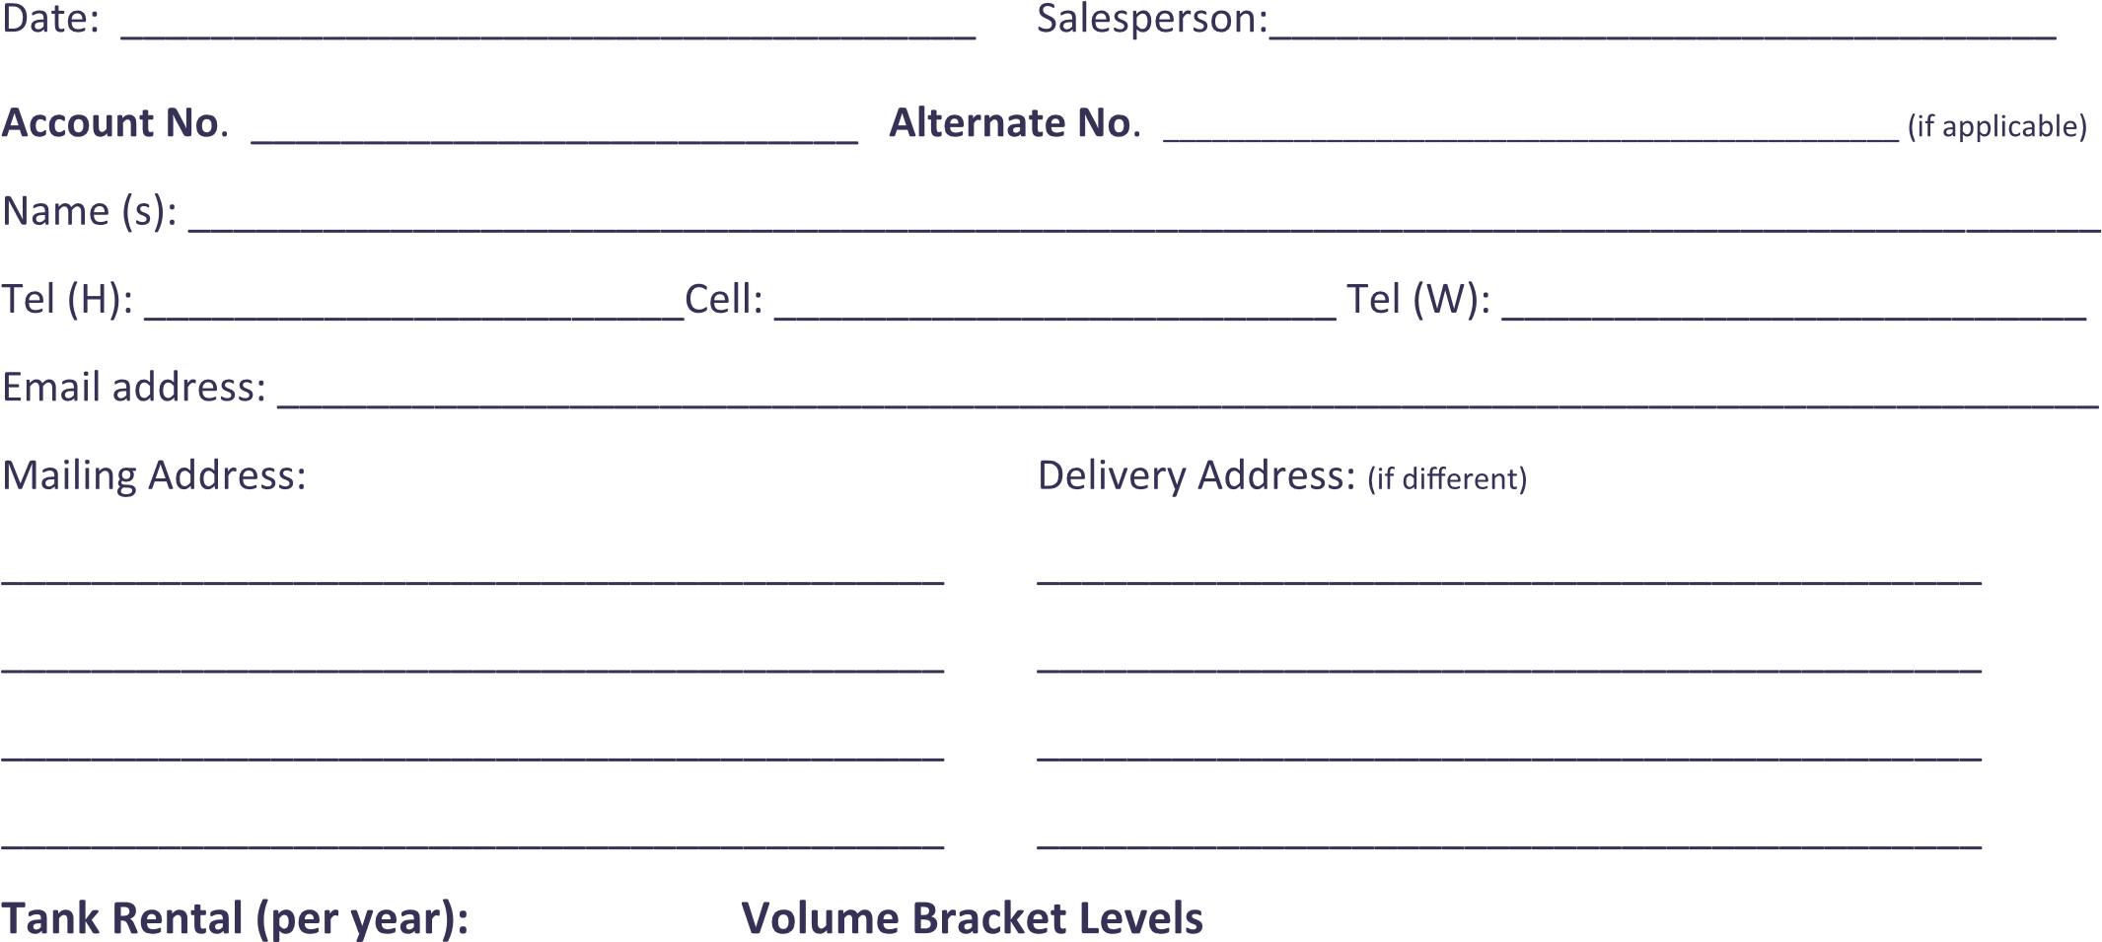

|  |  |  |  |
| --- | --- | --- | --- |
|  |  |  |  |
|  |  |  |  |
|  |  |  |  |
|  |  |  |  |
|  |  |  |  |
|  |  |  |  |
|  |  |  |  |

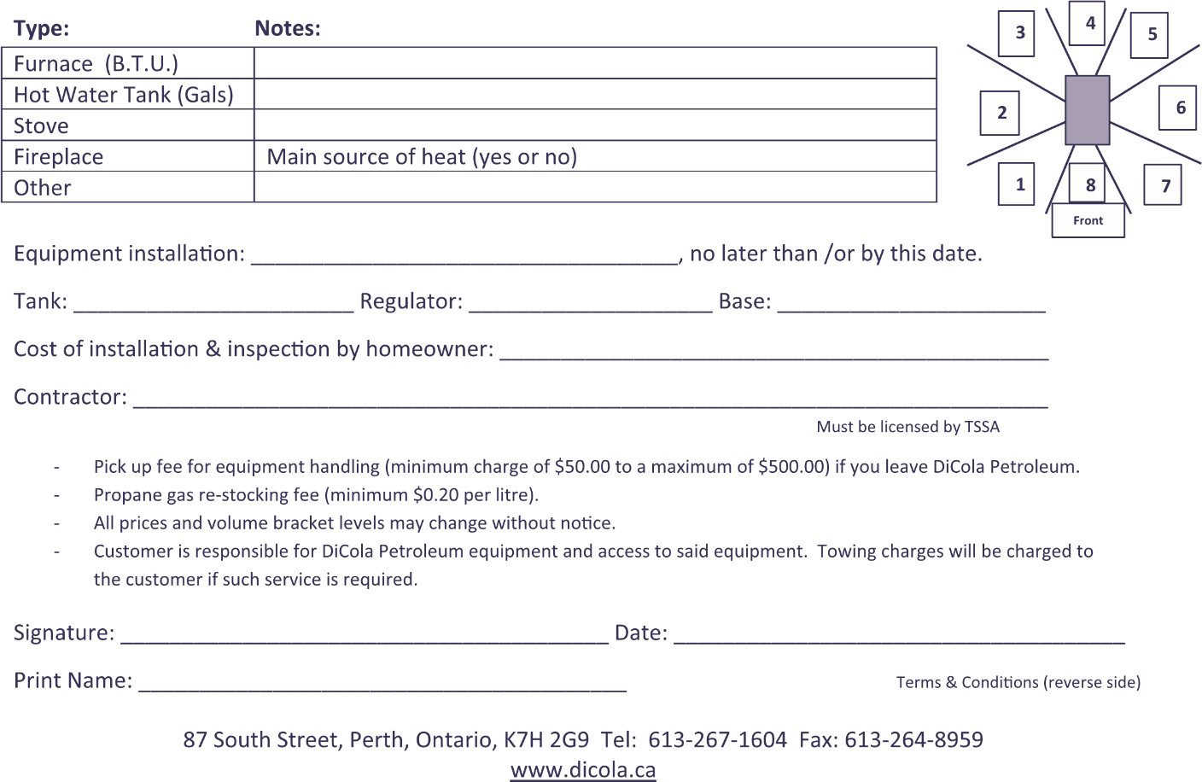



Terms & Conditions

1.

Upon credit approval.

2.

Terms of payment on charged accounts a

re 30 days from delivery.

Interest charges are applicable on

overdue balances at a rate of 2% monthly.

3.

Existing customers with multiple commodities are subject to their original terms of payment.

4

.

Deliveries will be temporarily suspended on past due accounts until brought up-to-date.

5.

Payment options:

a)

At y

our local DiCola Petroleum office

b)

By mail

c)

At your financial institution

d)

Online ba

nking (add DiCola Petroleum as a payee)

6.

A $25.00 fee will apply on payment chargebacks.

7.

All accounts designated as "ON CALL" require a minimum of 72 hours' notice for delivery of propane.

If

an immediate delivery is requested, a service call of $100.00 or more will be charged to your account.

8.

A refundable deposit is required for tenants, restaurants and chip stands. The amount of the deposit is

determined by the size and number of tanks at the location being serviced. The deposit will be refunded

when the account is paid in full and closed.

9.

When damage to a cylinder from vehicular traffic is a possibility, protection shall be provided in

compliance with the requirements of the equipment installation, at the owner's expense.

In accordance

with "Article 5.3.2 from the Propane Storage and Handling Code" (CAN/CSA-8149.2-05).

10.

Any installation for a period of twelve (12) months or less will be considered as a temporary installation.

A fee of $250.00 will apply to cover costs of tank(s), delivery, install, and pick up of equipment.

11.

An inspection report is required, at the customer's expense, for all installations or any modifications. An

inspection is valid for ten (10) years, after which a new inspection is required.

12.

It will be the customer's responsibility for any fees charged for a site visit by a T.S.S.A. representative or

any other jurisdiction representative.

13.

If the customer sells or gives up occupancy of the premises where the equipment is installed, the

customer will pay or will be responsible for payment of their account balance and any additional fees

under the terms of this contract. Additional fees may be applicable unless the new occupant of the

premise signs a new contract with DiCola Petroleum and is approved by DiCola Petroleum.

14.

I confirm that all information provided to be true and accurate.

I have read and understand the following terms & conditions set forth.

Signature:

________________

Dated on: ______________

Print Name: _____________

___